Batch: B2 Roll No.: 16010121200

Experiment No. 9

Grade: AA / AB / BB / BC / CC / CD /DD

Signature of the Staff In-charge with date

TITLE: Implementation of Memory Allocation Algorithms
_____________________________________________________________________

AIM: To learn about various Memory Allocation Algorithms
___________________________________________________________________
Expected Outcome of Experiment:

CO 5. Understand Storage management with allocation, segmentation & virtual memory concepts
____________________________________________________________________
Books/ Journals/ Websites referred:

- Silberschatz A., Galvin P., Gagne G. “Operating Systems Principles”, Willey Eight edition.
- Achyut S. Godbole , Atul Kahate “Operating Systems” McGraw Hill Third
Edition.
- William Stallings, “Operating System Internal & Design Principles”, Pearson.
- Andrew S. Tanenbaum, “Modern Operating System”, Prentice Hall.

_____________________________________________________________________
Pre Lab/ Prior Concepts:

Knowledge of types of memory

Stepwise-Procedure:
Next Fit:
      - Select a process.
      - Current memory block is the block where the searching was last halted.
      - If the selected process can be assigned to the current memory block, then allocate the process with the required memory. Else check the next memory block.
      - Repeat step 3 until the process is allocated memory, else if process does not fit into any memory block, suspend the process.
      - Repeat steps 1-4 till all processes are either allocated memory or suspended.
Best Fit:
      - Select a process.
      - Current memory block is the starting memory block.
      - Calculate the memory hole size (i.e. memory unused) for each block, if the selected process is allocated to it.
      - Process is allocated to the block where the hole size is minimum.
      - Repeat steps 1-4 till all processes are either allocated memory or suspended.
Algorithms Used:
Next Fit:
This algorithm searches along the list looking for a segment that is large enough to accommodate the process.
Unlike First Fit, if the search is interrupted in between, new search is carried out from the last location instead of starting from the beginning.
Best Fit:
This algorithm searches through the list of free blocks of memory to find the block that is closest in size to the memory request from the process.

Implementation details: (printout of code)
import sys

def nextFit(memory, processes):
processNames = list(processes.keys())
allocation = { k : "" for k in processNames}
memoryBlocks = [list(x) for x in zip(memory.items(), [True] * (len(memory)))]
i = 0
for process, requirement in processes.items():
for j in range(4):
(block, size), avail = memoryBlocks[i]
if size >= requirement and avail:
allocation[process] = block
memoryBlocks[i][1] = False
break
i = (i + 1) % 4
else:
allocation[process] = 'No memory available'
print("Memory Allocation according to Next Fit:")
printTable(allocation)
return

def bestFit(memory, processes):
processNames = list(processes.keys())
allocation = { k : "" for k in processNames}
for process, requirement in processes.items():
memoryBlocks = list(memory.keys())
holeSize = { k : sys.maxsize for k in memoryBlocks}
for block, size in memory.items():
if size >= requirement:
holeSize[block] = size - requirement
minHoleSize = min(holeSize.values())
try:
block = [key for key in holeSize if holeSize[key] == minHoleSize][0]
allocation[process] = block
del memory[block]
except IndexError:
allocation[process] = 'No memory available'
print("Memory Allocation according to Best Fit:")
printTable(allocation)
return

def printTable(allocationTable):
for process, block in allocationTable.items():
print(process, block, sep = ' : ')
print()

memoryBlocks = {
'Block A' : 200,
'Block B' : 300,
'Block C' : 150,
'Block D' : 400,
'Block E' : 100
}

processRequirement = {
'Process 1' : 250,
'Process 2' : 150,
'Process 3' : 200,
'Process 4' : 300
}

print("Initial memory blocks:")
printTable(memoryBlocks)
print("Process requirements:")
printTable(processRequirement)
nextFit(memoryBlocks, processRequirement)
bestFit(memoryBlocks, processRequirement)

Output:

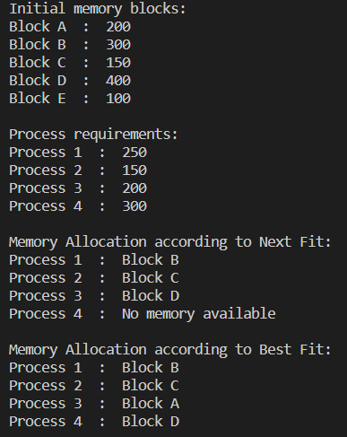

Conclusion:

Understood storage management with different memory allocation algorithms – First Fit, Next Fit, Best fit, Worst Fit.
Implemented the next fit and best fit memory allocation algorithms.

Date: 16/10/2023 Signature of faculty in-charge

